**NAME: M.LAVANYA  
 ROLL NO.: 21B21A4616  
 Topic: Git & Git Commands**

**DATE:16-02-2025**

**GIT:** What is Git?

* Git is a distributed version control system (VCS) for tracking changes in source code.
* It helps developers collaborate efficiently on projects.
* Supports branching, merging, and rollback features.
* Maintains a history of changes, allowing version control.
* Developed by Linus Torvalds in 2005.

**Definition of Git:**

* Git is an open-source, distributed version control system.
* Designed to handle small to large projects efficiently.
* Enables tracking, collaboration, and code management.
* Supports fast and secure development workflows.
* Used for software development, DevOps, and automation.
* **SET UP OF GIT IN V.S CODE:**Firstly we need to create a new folder in system, then you need to open the file in V.S code and create a file in the folder with any extension you want, then write the code in the file, then you need open the terminal and start running following commands given below:  
  **STEPS:**

*1. Initialize a Git Repository*

* Initializes an empty Git repository in the current directory.
* Creates a. git folder that stores all version control information.  
    
  **COMMAND:** git init

*2. Add Files to Staging Area*

* Stages all modified and new files for the next commit.

**COMMAND:** git add.

*3. Commit Changes*

* + Commits the staged changes with a message (-m flag).
  + The commit message should be meaningful to describe the changes.  
      
    **COMMAND:** git commit -m "<message>"

4. Set Up a Remote Repository

* Links the local repository to a remote repository on GitHub.  
  **COMMAND:** git remote add origin <repository-URL>
* By Coping edit

git remote add origin <https://github.com/lavanamoram/project1.git>

This associates the remote repository at GitHub with the local repository.

*5. Create and Rename the Main Branch*

Renames the default branch to main.

**COMMAND:** git branch -M main.

*6. Push Changes to GitHub*

* Pushes the main branch to the remote repository (origin).
* The -u flag sets origin main as the default upstream branch for future git push commands.  
  **COMMAND**: git push -u origin main

*7. Create a New Branch*

* Creates a new branch named new-branch-lavanya.  
   **COMMAND**: git branch new-branch-lavanya.

*8. Switch to a Different Branch*

* Switches to the Lavanya branch.

If the branch does not exist locally, Git will throw an error.

**COMMAND:** git checkout lavanya

*9. Fetch Remote Branches*

* Retrieves information about branches from the remote repository without merging them into the local branches.

**COMMAND:** git fetch

*10. Check Out a Remote Branch Locally*

* If the lavanya branch exists on the remote repository, but not locally, fetching first is required:

**COMMAND** git checkout lavanya

* Then, the following command creates and switches to the remote branch locally:

git checkout lavanya

* This sets up tracking for the remote lavanya branch.

*11. List All Branches*

* Displays all local branches.
* The current branch is marked with an asterisk (*).  
   **COMMAND** git branch.

*12. List Local Branches:*

* *This shows all local branches, with the current branch highlighted.***COMMAND** git branch –list

*13. List All Remotes:*

* This shows the names and URLs of all remotes.

**COMMAND** git remote - v

*14. Git Clone:*

* The git clone command is used to create a copy of an existing remote or local repository. This is commonly used to download code from a remote Git repository (such as GitHub, GitLab, or Bitbucket) onto a local machine.

**COMMAND** git clone <repository-URL> [directory-name]

git clone --branch <branch-name> <repository-URL>

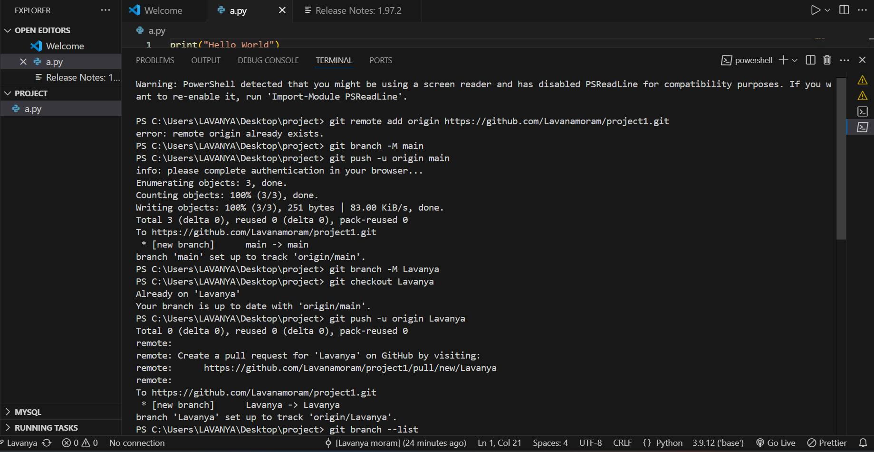

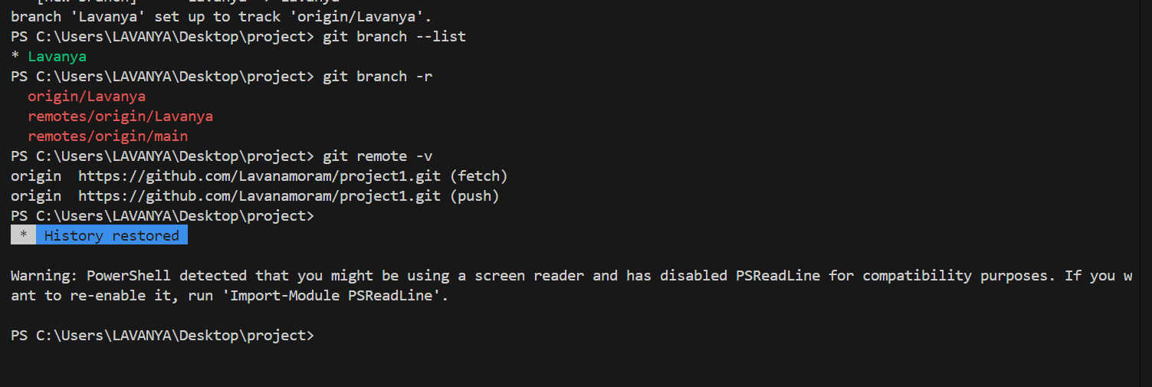

**CONCLUSION:**These commands help in initializing a Git repository, tracking changes, managing branches, and pushing code to a remote repository. Proper use of these commands ensures smooth version control and collaboration using Git.